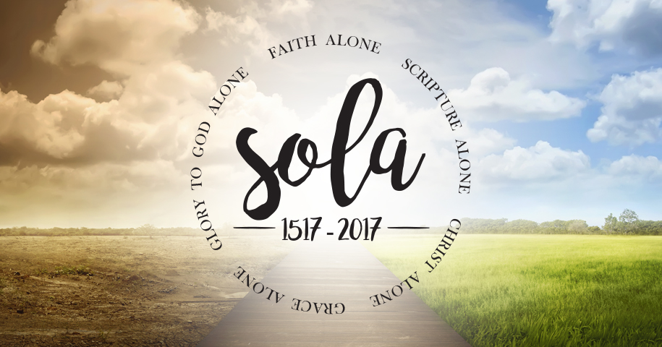
Scripture Alone
1st in “Sola” Series
2 Timothy 3:14-17 p. 996
October 8, 2017
Pastor Mickey Klink

7) Read 1 Peter 1:10-12. How do these verses add further explanation
regarding the inspiration of Scripture?

8) If God really did author Scripture – and we believe he did (!), how should
that fact affect how we revere and live under the Word of God? Give
examples of what this should look like.

9) In. vv. 16-17 the text gives ways that Scripture is profitable for the
Christian. How has Scripture been profitable in your own life?

10) How would a person know if they were really submitting their lives to the
Word of God? Asked another way: what are the symptoms of a life that is
truly committed to “Scripture Alone?”

Further study this week: 1 Peter 1:10-12 on the inspiration of Scripture (Mon); Psalm 119 (esp. vv. 18 and 105) on the blessings of God’s Word (Tues); Psalm 138 (esp. v. 2) on the exaltation of God’s Word (Wed); Romans 15:1-7 (esp. v. 4) on Scripture’s encouragement (Thurs); Colossians 3:1-17 on dwelling on the Word of God (Fri).

PRAYER REQUESTS:
__________________________________________________________________________________________________________________________________________________________________________________________________________________________________________________________________________________________________________________________________________________________________________________________________________________________________________________________________________________________________________________________________________________________________________________________________________________

Introduction

Introduction
In this sermon we listen to the church’s cry for “Scripture alone,” and apply it to our life and ministry.

The Text: 2 Timothy 3:14-17

- “The Five Solas” are slogans that summarize key aspects of the historic Christian faith and the gospel.

- The slogan “Scripture Alone” is clearly derived from God’s Word (2 Timothy 3:14-17).

- The slogan “Scripture Alone” has several applications for the Christian and the church.

a) Scripture is our highest authority.
“The Holy Scriptures are the only sufficient, certain, and infallible standard of all saving knowledge, faith, and obedience.” (LBC 1.1)

b) Scripture derives its authority from God.
“The authority of the Holy Scriptures obligates belief in them. This authority does not depend on the testimony of any person or church but on God the author alone, who is truth itself. Therefore, the Scriptures are to be received because they are the Word of God.” (LBC 1.4)

c) Scripture is complete in what it teaches.
“The whole counsel of God concerning everything essential for his own glory and man’s salvation, faith, and life is either explicitly stated or by necessary inference contained in the Holy Scriptures. Nothing is ever to be added to the Scriptures, either by new revelation of the Spirit or by human traditions.” (LBC 1.6)

d) Scripture is clear in what it teaches.
“Some things in Scripture are clearer than others, and some people understand the teachings more clearly than others. However, the things that must be known, believed, and obeyed for salvation are so clearly set forth and explained in one part of Scripture or another that both the educated and uneducated may achieve a sufficient understanding of them by properly using ordinary measures.” (LBC 1.7)

e) Scripture is useful and necessary for everyone.
“All God’s people have a right to and a claim on the Scriptures and are commanded in the fear of God to read and search them. Not all of God’s people know these original languages, so the Scriptures are to be translated into the common language of every nation to which they come. In this way the Word of God may dwell richly in all, so that they may worship him in an acceptable manner and through patience and the comfort of the Scriptures may have hope.” (LBC 1.8)

f) Scripture’s parts interpret the whole, and the whole interprets the parts.
“The infallible rule for interpreting Scripture is the Scripture itself.” (LBC 1.9)

g) Scripture has the final say over all opinions and decisions.
“The supreme judge for deciding all religious controversies and for evaluating all decrees of councils, opinions of ancient writers, human teachings, and individual interpretations, and in whose judgment we are to rest, is nothing but the Holy Scripture delivered by the Spirit. In this Scripture our faith finds its final word.” (LBC 1.10)

Response

- In light of the 500th anniversary of the Reformation, how can we make sure we are holding to Sola Scriptura (Scripture Alone)?

Would you like to be involved in a Small group? Contact Pastor Brad at pastorbrad@hefc.net
Scripture Alone
2 Timothy 3:14-17

- How much authority does the Bible have in the lives of people in the world today?

- How much authority does the Bible have in the lives of people in the church today? What are some expectations or commands in the Bible for which it is difficult for Christians to obey or submit?

- Read the text aloud and discuss together any significant observations or issues needing clarification.

- How do vv. 14-15 suggest that there is value in being raised with Scripture? Tell your story and how you were or were not raised with a familiarity and reverence for God’s Word.

- What does v. 15 mean when it says that Scripture is “able to make you wise for salvation through faith in Jesus Christ?” Why use the word “wisdom?”

- What does v. 16 mean when it says that “all Scripture is breathed out by God?” Why do you think the church considered that statement one of the most significant explanations regarding the nature of the Bible?

