“Fear and Obey God”
24th in “The Good Life” Series
Ecclesiastes 12:9-14 pg. 559
July 9, 2017
Pastor Mickey Klink

7) How does the closing summary in v. 13, fear and obey God, serve as a
fitting summary of the message of Ecclesiastes?

8) What does it mean and look like to “fear and obey God?”

9) What is the relation of v. 14 to v. 13? Why might it be important to see that
God is a God of both grace and demand (judgment)?

10) How has the book of Ecclesiastes changed you – what you believe or how
you live?

Further study this week: Exodus 19 on obeying God (Mon); John 15:1-11 on Jesus the vine (Tues); 1 Corinthians 10:1-6 on taking every thought captive (Wed); 2 Timothy 3 on the authoritative Word of God (Thurs); Ecclesiastes 2:1-11 on everything vanity without Christ (Fri).

PRAYER REQUESTS:
____________________________________________________________________________________________________________________________________________________________________________________________________________________________________________________________________________________________________________________________________________________________________________________________________________________________________________________________________________________________________________________________________________________________________________________________________

Introduction

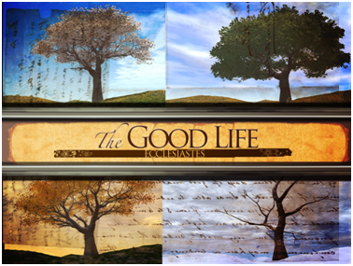

Introduction
In this passage God concludes Ecclesiastes and explains the blessed duty of each person: to fear and obey God.

The Text: Ecclesiastes 12:9-14

- Ecclesiastes ends with an “epilogue” that helps the reader receive and apply the book’s message (vv. 9-10).

- The purpose of Ecclesiastes was to put wisdom into action – to live “the good life” (vv. 11-12).

- The message of Ecclesiastes can be summarized this way: “fear and obey God” (vv. 13-14).

Response

- Have you been converted yet from “vanity” to “Christianity” – to the Good Life in God?

Would you like to be involved in a Small group? Contact Pastor Brad at pastorbrad@hefc.net
Fear and Obey God
Ecclesiastes 12:9-14

- Read the text aloud and discuss together any significant observations or issues needing clarification.

- In epilogues (or literary conclusions) of ancient texts, the author often spoke in the third person. How else does this passage signal to the reader that it is a closing statement?

- What is the epilogue trying to communicate to or instruct the reader?

- In v. 11, “goads” are ancient cattle-prods, and nails, as you know, make things attach. What are those images intending to communicate to the reader regarding God’s Word?

- V. 11 is remarkable in that it describes the words of wisdom in Ecclesiastes as the words of the Shepherd – God. How does this verse teach that the Bible is not simply the word of men but also the Word of God? Why is that significant?

- How does v. 12 warn against making any book more important and authoritative than the Bible? Note: be careful not to read the end of this verse as if reading other books and the life of the mind were unimportant.

