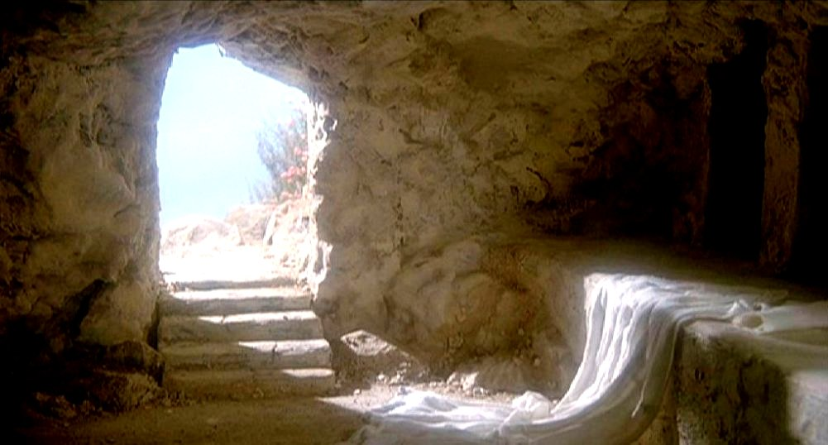
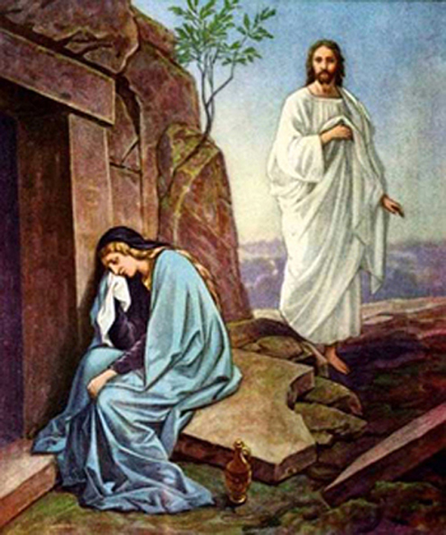
“Jesus is Easter”
Colossians 1:15-20 p. 983
April 16, 2017
Pastor Mickey Klink

7) If you are a believer and the resurrected Jesus is now the source of your life,
how does that change the way you look at life and the things in this world?

8) In the same way, if the resurrected Jesus is now the source of your life, how
does that change the way you look at death?

9) How do you avoid allowing the annual celebration of Good Friday and
Easter from becoming a life-less tradition?

10) Easter is more than brunch, egg hunts, and chocolate; Easter is about Jesus.
How should Good Friday and Easter (even Holy Week) help us direct our
attention again to Jesus?

PRAYER REQUESTS:
__________________________________________________________________________________________________________________________________________________________________________________________________________________________________________________________________________________________________________________________________________________________________________________________________________________________________________________________________________________________________________________________________________________________________________________________________________________

Introduction

Introduction
In this sermon we learn that the church annually celebrates Easter to direct us to what matters most – Jesus.

The Text: Colossians 1:15-20

- Easter celebrates the climactic moment in the story of the Bible (vv. 15-16).

- Easter shows how Jesus is the most important thing in the world (vv. 17-18).

- The gift Easter offers is not a better life – it is a new life (vv. 19-20).

Response

- Easter gives us the annual opportunity to focus on the most important thing – Jesus.

Would you like to be involved in a Small group? Contact Pastor Brad at pastorbrad@hefc.net
Jesus is Easter
Colossians 1:15-20
- Read Colossians 1:15-20 aloud and discuss together any significant observations of issues needing clarification.

- What makes this passage from Scripture fitting for Good Friday and Easter?

- The term “firstborn” in v. 15 does not mean “first created” but is a “title of preeminence or greatness.” How is that title being applied to Jesus in this context?

- In v. 17 Paul emphasizes that all things were created “by” Jesus, with no power or authority having existence outside of him. What is the significance of that?

- Jesus, the Creator of all things, came to his creation in order to die for it. How does that change the way we should celebrate Good Friday and Easter?

- If “firstborn” in v. 16 is a title of preeminence/greatness, what might it mean in v. 18?

