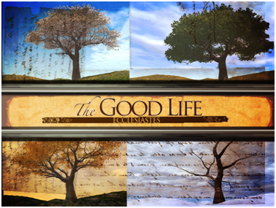
“Choose Wisdom”
Ecclesiastes 7:1-12 pg. 556
April 23, 2017
Pastor Mickey Klink

7) Apply vv. 5-6 to your life: why is it wiser to receive rebukes and
constructive criticism than simply to pursue ease and comfort?

8) The Preacher gives important warnings in vv. 7-10. What reasons does the
text give for these warnings from God about the topics of power (v. 7),
impatience (v. 8), anger (v. 9), and nostalgia (v. 10)? How might you apply
these warnings to your own life?

9) The Bible describes “wisdom” as natural, smart decision-making and as
more spiritual, God-given insight into the deeper things of life. How can we
treat wisdom as an “inheritance” (v. 11) and as valuable as “money”
(v. 12)?

10) How does this text help you think differently about your own life? What
practical applications does this text encourage you to make?

PRAYER REQUESTS:
__________________________________________________________________________________________________________________________________________________________________________________________________________________________________________________________________________________________________________________________________________________________________________________________________________________________________________________________________________________________________________________________________________________________________________________________________________________

Introduction

Introduction
In this passage God explains that the Good Life is one that chooses wisdom over folly.

The Text: Ecclesiastes 7:1-12

- Choose the funeral over the party (vv. 1-4).

a) Inner character is better than outer fragrance (v. 1a)

b) The reality of death gives perspective and helps us take life (and God)
seriously (vv. 1b-4).

- Choose the road less travelled over the express lane (vv. 5-10).

a) Rebukes and constructive criticism are better than silliness and
sarcasm (vv. 5-6).

b) Wisdom seeks a godly perspective and purpose in all circumstances
(vv. 7-10).

- Choose wisdom – if you want to live the Good Life and to honor your God (vv. 11-12).

Response

- The Good Life is a life that chooses wisdom over folly.

Would you like to be involved in a Small group? Contact Pastor Brad at pastorbrad@hefc.net
Choose Wisdom
Ecclesiastes 7:1-12

- Read the text aloud and discuss together any significant observations or issues needing clarification.

- Wisdom literature consists of general truths for application, is often written in the form of parallelisms, and often uses shocking, contrasting statements to make a point. How does understanding these traits help you interpret this passage, but especially v. 1?

- Not all contrasting statements give their own interpretation, but v. 2 and v. 3 do (beginning at “for”). What is the application take-away from those verses?

- How is reading wisdom literature like Ecclesiastes (or Psalms or Proverbs) different than reading a historical narrative (Acts) or a letter (1 Corinthians)? In what ways might God use wisdom literature to minister to us in ways narratives and letters cannot?

- Vv. 1-4 are set in the context of a funeral (e.g., death, mourning, sorrow). How does the reality of death give us a wise perspective and help us take life (and God) seriously?

- Read Luke 9:23-24, Romans 6:11, Philippians 1:20-24, and Colossians 3:3, 5. How do these texts use the theme of “death” to describe various aspects of the Christian life?

